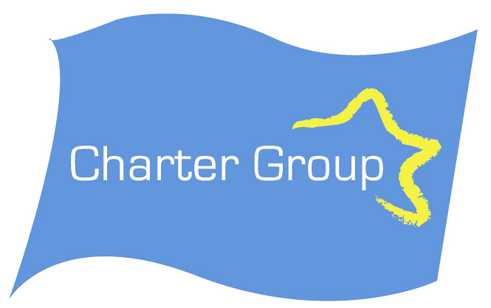

Joe Higgins MEP is incorrect to claim that the change to the Charter text was just a textual error.

The Secretary of the Charter Group Blair Horan said this evening that Joe Higgins MEP was incorrect to present the change to Article 52 made in his Press Release as only a textual error. The change which involved deleting (which) and adding (and) changed the meaning of Article 52 entirely.
It had the effect of subjecting all of the Charter Articles to the Treaty. This allowed Joe Higgins MEP to argue that the Charter was subject to the market. (Treaty Article 81 on Competition)
In fact the correct Article 52 wording refers to rights in the Charter that come directly from the Treaty itself and states that they have the same meaning. It would be rather odd if they had a different meaning.
Joe Higgins MEP states that this was a genuine error. I am not going to accuse him of personal dishonesty, but somebody on his team made this change and conveniently it changes the meaning of the Article and strongly supports their interpretation of the Charter. If this was the correct wording it would render the Charter meaningless as it would not add to the Treaty. There is no basis for Joe Higgins interpretation of the Charter based on the correct wording.
In addition to the Treaty itself the main sources of the Charter are
- The European Convention on Human Rights.
- The European Social Charter
- The Community Charter on the Fundamental Social Rights of Workers.

Wording agreed at Nice Council 2000

Rights recognised by this Charter which are based on the Community Treaties or the Treaty on European Union shall be exercised under the conditions and within the limits defined by those Treaties.
The wording in the Press Release deleted which and added and shall be... This alters the meaning completely. In December 2007, the reference in Article 52 to Community and Union Treaties was simplified to “for which provision is made in the Treaties”. This is purely textual and does not change the meaning as the alteration by Mr Joe Higgins or one of his team did.

For Further information contact Blair Horan at 087 2561888

